Trail making Test TMT Parts A and B

<http://apps.usd.edu/coglab/schieber/psyc423/pdf/IowaTrailMaking.pdf>

Instructions: Both parts of the Trail Making Test consist of 25 circles distributed over a sheet of paper. In Part A, the circles are numbered 1 – 25, and the patient should draw lines to connect the numbers in ascending order. In Part B, the circles include both numbers (1 – 13) and letters (A – L); as in Part A, the patient draws lines to connect the circles in an ascending pattern, but with the added task of alternating between the numbers and letters (i.e., 1-A-2-B-3-C, etc.). The patient should be instructed to connect the circles as quickly as possible, without lifting the pen or pencil from the paper. Time the patient as he or she connects the "trail." If the patient makes an error, point it out immediately and allow the patient to correct it. Errors affect the patient's score only in that the correction of errors is included in the completion time for the task. It is unnecessary to continue the test if the patient has not completed both parts after five minutes have elapsed.

Step 1: Give the patient a copy of the Trail Making Test Part A worksheet and a pen or pencil.

Step 2: Demonstrate the test to the patient using the sample sheet (Trail Making Part A – SAMPLE).

Step 3: Time the patient as he or she follows the “trail” made by the numbers on the test.

Step 4: Record the time.

Step 5: Repeat the procedure for Trail Making Test Part B.

Scoring: Results for both TMT A and B are reported as the number of seconds required to complete the task; therefore, higher scores reveal greater impairment.

Average Deficient Rule of Thumb

Trail A 29 seconds > 78 seconds Most in 90 seconds

Trail B 75 seconds > 273 seconds Most in 3 minutes

Sources:

• Corrigan JD, Hinkeldey MS. Relationships between parts A and B of the Trail Making Test. J Clin Psychol. 1987;43(4):402–409.

• Gaudino EA, Geisler MW, Squires NK. Construct validity in the Trail Making Test: what makes Part B harder? J Clin Exp Neuropsychol. 1995;17(4):529-535.

• Lezak MD, Howieson DB, Loring DW. Neuropsychological Assessment. 4th ed. New York: Oxford University Press; 2004.

• Reitan RM. Validity of the Trail Making test as an indicator of organic brain damage. Percept Mot Skills. 1958;8:271-276.

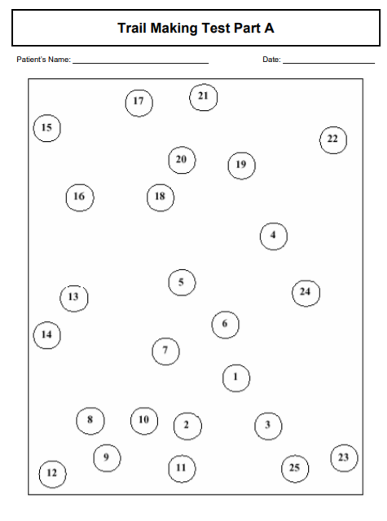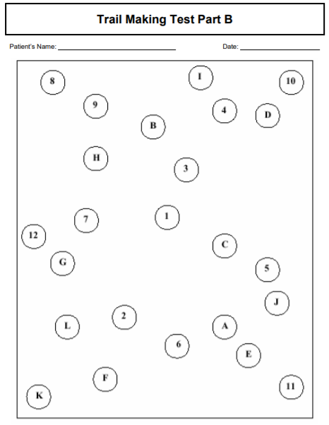

<https://www.verywellhealth.com/dementia-screening-tool-the-trail-making-test-98624>

TMT Scoring

The Trail Making Test is scored by how long it takes to complete the test. If a person makes an error in the test, there’s no change in the score other than that it makes their completion time longer since the person has to go back to the previous circle, thus extending their time.

Acceptable Scores

According to the TMT directions for administration, an average score for the TMT Part A is 29 seconds and a deficient score is greater than 78 seconds.

For the TMT Part B, an average score is 75 seconds and a deficient score is greater than 273 seconds.

The results of the TMT were found to be influenced significantly by age; as people age, they require a longer time to complete the TMT. How many years of education the person received only slightly impacted the results.

Effectiveness of Screening

The TMT measures attention, visual screening ability and processing speed, and is a good measure of overall cognitive functioning.

Part A is a good measure of rote [memory.](https://www.verywellhealth.com/types-of-memory-explained-98552) Part B is generally quite sensitive to [executive functioning](https://www.verywellhealth.com/executive-functioning-alzheimers-98596)since the test requires multiple abilities to complete it. The TMT Part B has also been suggested as a useful tool to evaluate if a loved one with dementia [can safely drive](https://www.verywellhealth.com/what-not-to-do-to-people-with-alzheimers-disease-97967) since it requires [visual ability](https://www.verywellhealth.com/how-does-dementia-affect-visual-spatial-abilities-98586), [motor functioning](https://www.verywellhealth.com/what-is-the-allen-cognitive-level-screen-4129962), and cognitive processes.

The Oral Trail Making Test

The Trail Making Test can also be administered orally. Rather than giving the person a piece of paper and pen, you can simply ask the person to count from 1 to 25 (Part A). For Part B, the person is asked to verbally recite numbers and letters, alternating between numbers and letters like this: 1-A-2-B-3-C etc. The oral version of the TMT can be a quick tool to assess cognition when the person physically is unable to perform the written test or in situations like a hospital where illness and fatigue could affect the written results.

Pros and Cons

**Pros**

It's free to use, while [other tests](https://www.verywellhealth.com/the-clock-drawing-test-98619) incur a cost each time they're administered.

It's brief, taking only about five minutes to administer.

Part B has been shown to be a good measure of executive functioning. Tests that only measure [memory](https://www.verywellhealth.com/types-of-memory-explained-98552) or [word-finding ability](https://www.verywellhealth.com/alzheimers-disease-and-word-finding-difficulties-98554) may miss impaired executive functioning and thus not detect some [types of dementia](https://www.verywellhealth.com/types-of-dementia-98770).

**Cons**

Older age generally affects performance, even in the absence of any cognitive impairment, but this is not taken into account in the scoring.

Some research found that the TMT would exclude a significant number of capable drivers if it was solely relied upon to evaluate driving ability, while other studies found it missed other impairments that would endanger the driver or those around him.

Mini-Mental State Exam (MMSE) and the Mini-Cog test

<https://www.alz.org/alzheimers-dementia/diagnosis/medical_tests>

The maximum **MMSE score** is 30 points. A **score** of 20 to 24 suggests mild dementia, 13 to 20 suggests moderate dementia, and less than 12 indicates severe dementia. On average, the **MMSE score** of a person with Alzheimer's declines about two to four points each year.

<http://img.medscape.com/article/737/054/MMSE.pdf>

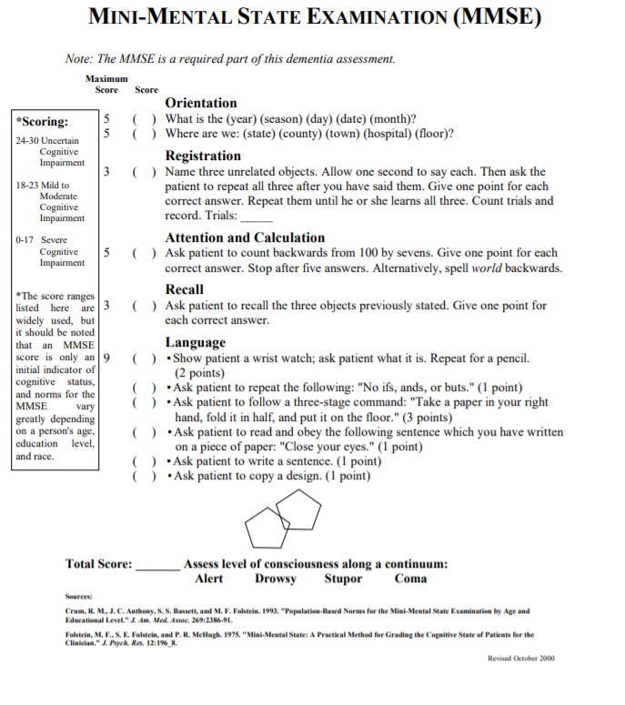

The Logical Memory (LM)

Chapman et al. Alzheimer's Research & Therapy (2016) 8:9 DOI 10.1186/s13195-016-0176-z  
<https://www.ncbi.nlm.nih.gov/pmc/articles/PMC4762168/pdf/13195_2016_Article_176.pdf>

The Logical Memory (LM) subtest of the Wechsler Memory Scale has been characterized by imprecise scoring instructions which can make data interpretation and study comparisons difficult. A total of 339 adults, from 18 to 83 years old, took either Form I or Form II of the LM. Verbal recall of the story passages was evaluated using gist and verbatim scoring systems. Interrater reliability was very high for both scoring approaches. The two forms were equivalent for gist recall. However, verbatim recall of Form I was more difficult than Form II because the former consists of more words to remember. Recall was related more to educational level than to age. For both gist and verbatim scoring, age and education norms were generated for immediate, delayed, and 24-h recall

Outcome Measure Wechsler Memory Scale-IV – Logical Memory subtest

<http://movingahead.psy.unsw.edu.au/documents/research/outcome%20measures/adult/Neuropsychological%20Impairment/Website%20WMS-IV%20LM.pdf>

Sensitivity to Change Yes

Population Adult

Domain Neuropsychological Impairment

Type of Measure Objective test

ICF-Code/s b1

Description Logical Memory is a subtest from the Wechsler Memory Scale IV that comprises part of the Auditory Memory Index.

It is also present in earlier versions (revised and III). Individuals are read a short prose passage and asked to recall as many details as possible both immediately and after a 25-35 minute interval. A yes/no recognition test follows the delay. This test takes approximately 5 minutes to administer (however sufficient time must be available to include the delay). Properties Internal Consistency:

The technical manual states that internal consistency in a sample of adults aged 16-69 was .82 for LM I and .85 for LM II. For a group of 32 adults with moderate to severe TBI, internal consistency was .88 for LM I and .93 for LM II.

Test-retest reliability: .72 for LM I and .67 for LM II in a sample of 173 adults and with a test-retest interval ranging from 14 to 84 days (M=23).

Construct validity: LM correlates with other measures of memory function such as the CVLT II Short delay free recall (.40-.47), CVLT II long delay free recall (.45-.52), RBANS immediate memory index (.53-.57) and RBANS delayed memory index (.28-.49),

Concurrent validity: Increased forgetting rates on the LM subtest of the WMS-R have been shown in individuals with closed head injuries (Reid & Kelly, 1993). For a group of 32 adults with moderate to severe TBI, group mean differences in performance on LMI and LMII resulted in moderate and large effect sizes respectively.

Advantages

• Quick and easy to administer.

• Australian norms available.

• Strong psychometric properties.

• Well established measure of structured verbal memory.

Disadvantages

• Need to purchase entire WMS-IV.

• Heavily reliant on verbal abilities therefore not suitable for individuals with language disorders.

Additional Information Reviewers Skye McDonald References Wechsler, D., Holdnack, J. A., & Drozdick, L. W. (2009). Wechsler Memory Scale: Fourth Edition. Technical and Interpretive Manual. San Antonio: Pearson.

LM1 and LM2 Scoring

<https://images.pearsonclinical.com/images/products/WMS-IV/WMS-IV_Webinar_September_2011_Handout.pdf>

